**ASSIGNMENT-4(AP)**

**Name:** Saharsh Kumar

**UID:** 22BCS14059

**Section:** 22BCS_FL_IOT-604

**Group:** A

**1.)** **Number of 1 Bits**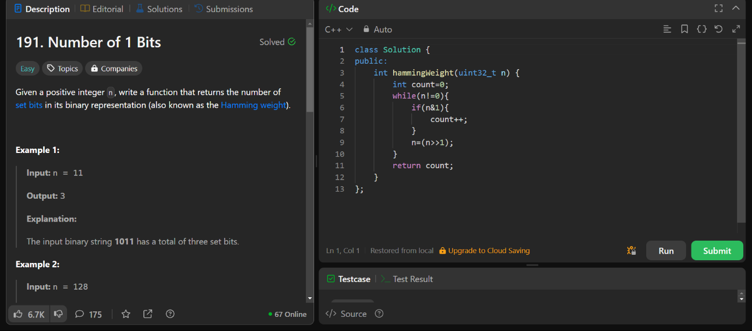

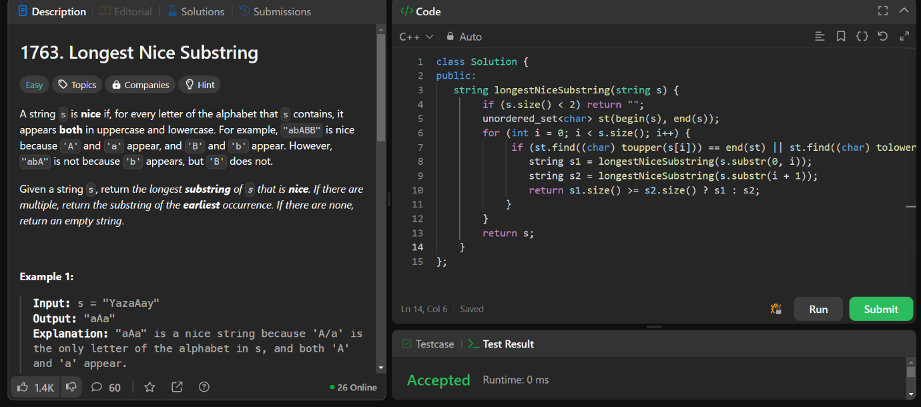**2.) Longest Nice Substring**

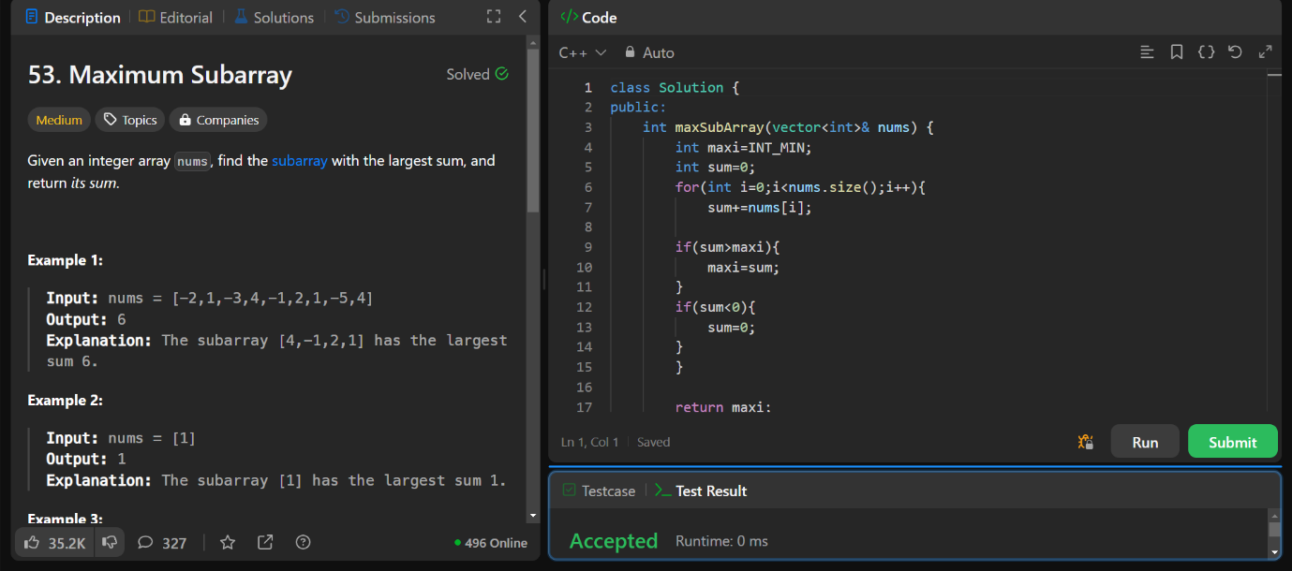**3.) Maximum Subarray**

**4.) Search a 2D Matrix II**

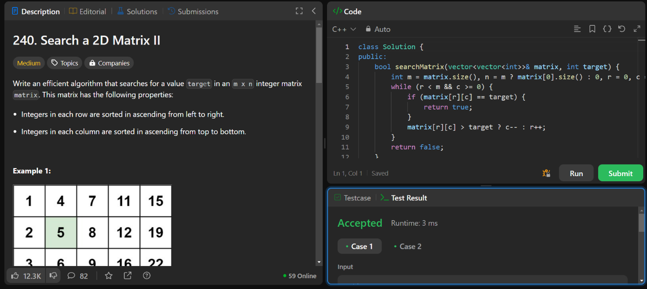

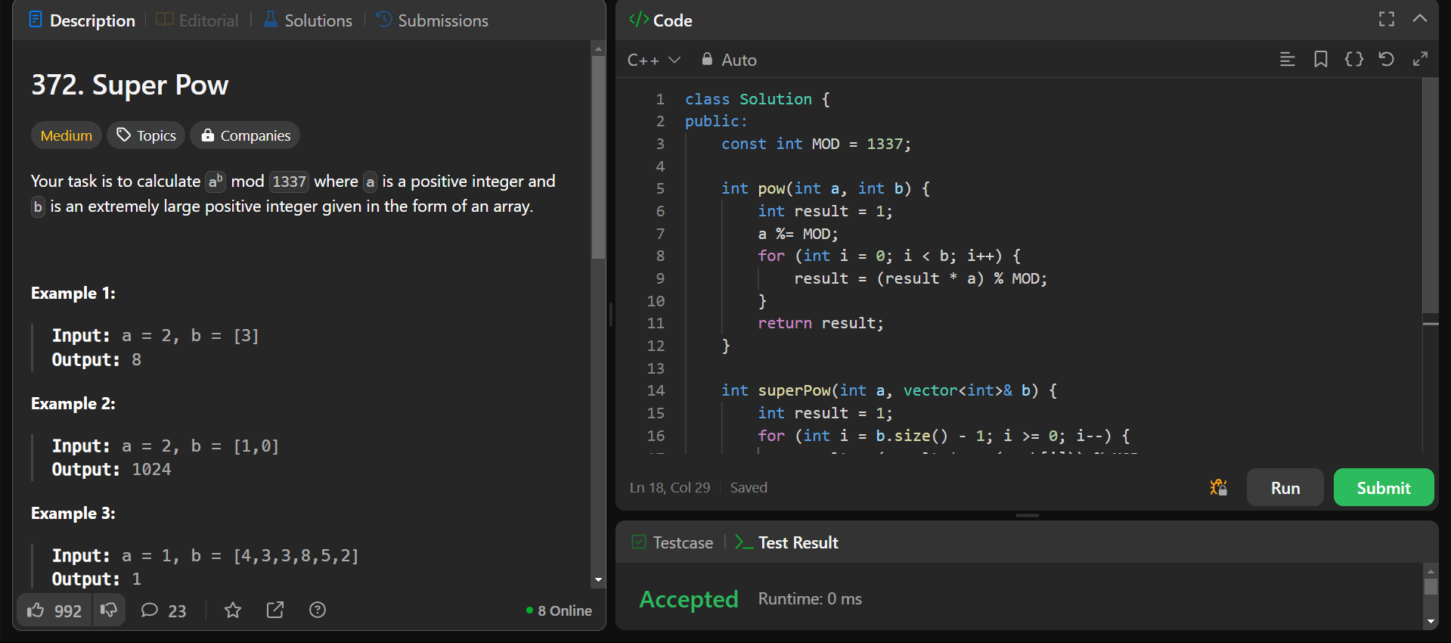**5.) Super Pow**

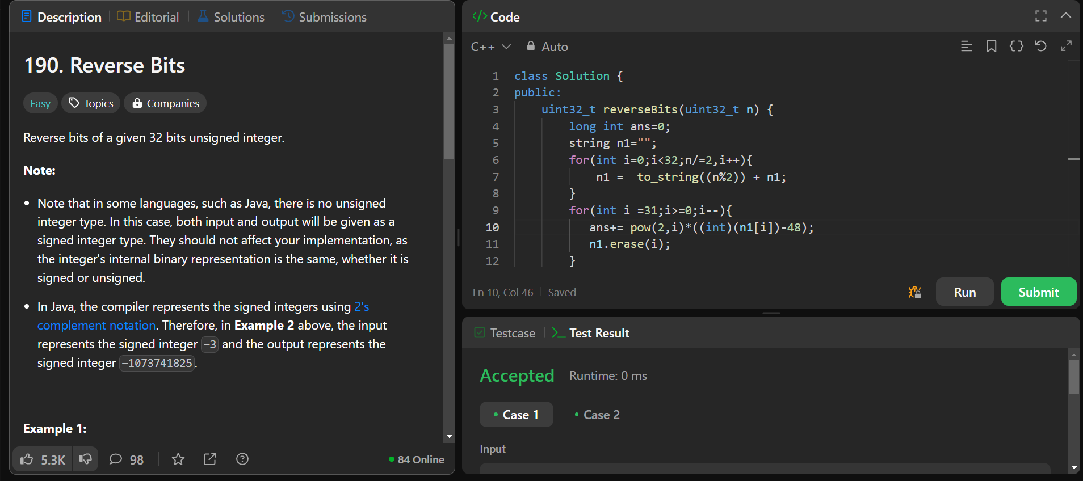**6.) Reverse Bits**